 |  | Consumer Research Expert
ConsumerInsight Report
(2020 Travel Report)
Company | ConsumerInsight |  | E-mail | kwonyg@consumerinsight.kr
Query | Kwon, Younggyo / Director |  | Phone Number | 02) 6004-7622
Issued | Friday, May 21, 2020 |  | Pages | Total of 3 pages

Domestic travel instead of overseas for Koreans? Not likely
- ConsumerInsight analyzes results of ‘Weekly tracking survey of Koreans traveling’
- ‘Travel spending intention’ turned worst for both domestic and overseas travel
after the spread of COVID-19
- ‘Intention to spend less’ surpassed ‘intention to increase’ in travel for the first time
since the survey started
- The long recession of the travel industry seemingly inevitable

Korean consumer intention to spend on travel has been falling over time, heading towards its record low. The study found the unprecedented result of consumer intention to ‘spend less’ outnumbering consumer intention to ‘spend more’ over the next year for both domestic and overseas. The result is not a simple reverse but rather a significant change, indeed.
The ecology of the travel industry severely hit by the novel Coronavirus infection (COVID-19) is facing a difficult crisis to handle. In fact, the outlook not only for overseas travel that is nearly on halt but also domestic travel looks gloomy, with COVID-19 standing in the very middle of it.
ConsumerInsight, a travel research specialized firm, asked Korean consumers about their intention to spend on travel in the next year for either domestic or overseas travel and analyzed the results in its ‘Weekly travel behavior and planning study’ (weekly sample of 500, or 26,000 respondents per year). The results were analyzed since 2017 and the fieldwork was done till the second week (17th) of May this year.
The survey results showed a steep decline in consumers’ intention to spend on both domestic and overseas. The response answering ‘will spend less’ in domestic travel came to 38%, the record high, since the beginning of the study [Figure 1]. On the other hand, ‘intention to increase travel spend’ declined to 27%, the lowest ever since the study started (monthly base). It is since last March when COVID-19 crisis surfaced in earnest that ‘intention to spend less’ outnumbered ‘intention to spend more’ in domestic travel, and the gap is growing bigger. When it comes to the gap between ‘spend more’ and ‘spend less,’ the gap for ‘spend more’ was +18%p (35%-17%) in 2019 which was, however, reversed greatly by the gap for ‘spend less’ by +11%p (38%-27%) in May this year.

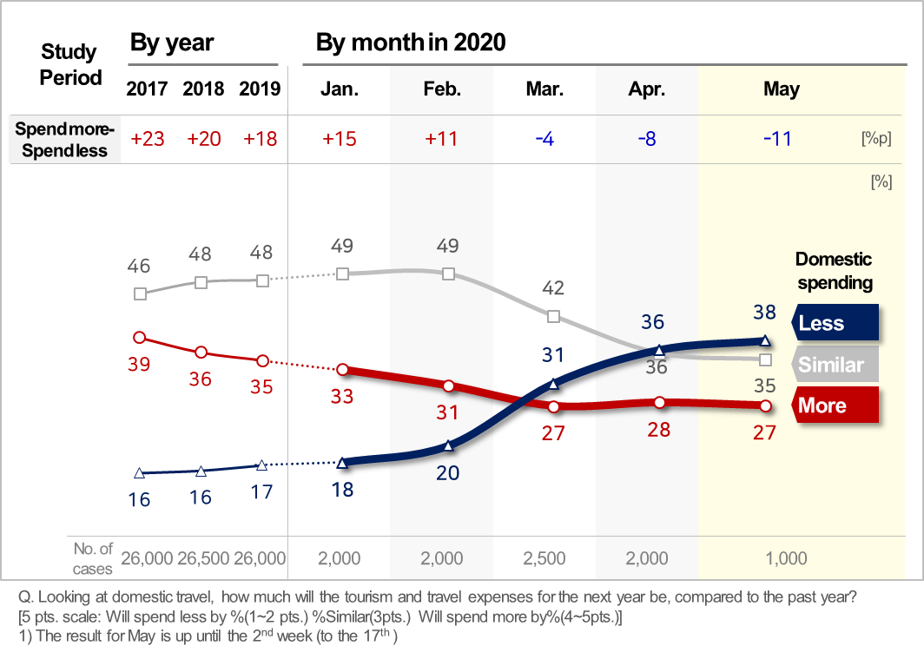
[Figure 1] Korean Consumers’ Intention to Spend on Domestic Travel

Overseas travel is even in a worse situation. ‘Intention to spend less’ on overseas travel increased by 2.5 times at 59% as of last May, compared to 24% in last January at the early stage of the crisis [Figure 2]. Rather, ‘intention to spend more’ came to only 17%. The gap between ‘spend more’ and ‘spend less’ was +15%p (39%-24%) for ‘spend more’ in 2019, but the same was badly reversed by the gap of +42%p for ‘spend less’ in May, this year. The hard-to-believe amount of change was made in those 5 months. Even considering that the current pandemic blocked the airways, the change in the 5 months was still ground-breaking.
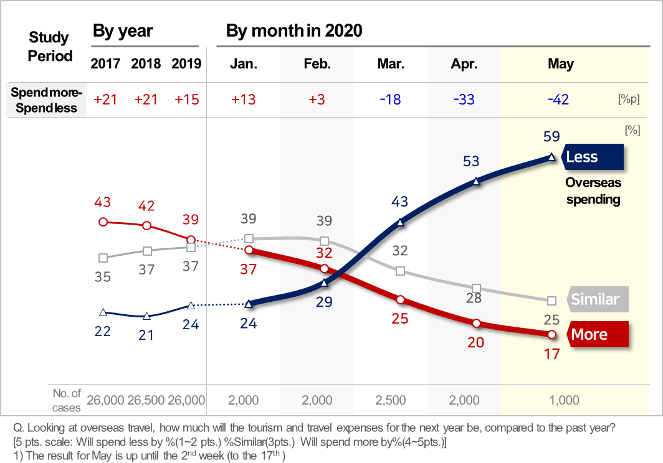
[Figure 2] Korean Consumers’ Intention to Spend on Overseas Travel
In fact, Korean consumers’ sentiments towards travel spending have been on a gradual decline since 2017, because of such subsequent negative factors as China’s three prohibitive measures in response to the deployment of THAAD, the Hungary ferry accident, 'NO Japan' movement, and the continuous sense of crisis on the real economy following recessions. Nevertheless, the seriousness lies in the fact that ‘intention to spend less’ surpassed ‘intention to spend more’ on travel, and what is even worse is that the size of the reversal is large enough to have a critical impact on the travel industry.
South Korea is considered to be one of the successful countries in fighting against COVID-19 in the wake of the pandemic. While Koreans are already living their everyday life without lockdown, their travel activities are likely to resume, sooner than other country in the world. Thus, Koreans’ travel behavior data will be used not only for setting up a marketing strategy to induce tourism but also be an effective indicator for predicting travelers’ behavior in their own countries.
ConsumerInsight Consumer Trend Research Lab conducts a syndicated survey ‘Weekly travel behavior and planning study’ with a weekly sample of 500 consumers (26,000 sample per year). Weekly updated survey results and analysis reports can be viewed at www.consumerinsight.co.kr/etravel and the summary of the survey results by year can be downloaded.

Copyright ⓒ Consumer Insight. All rights reserved. Cannot be used for commercial use.
For-more-Information
Kwon, Younggyo / Director | E. kwonyg@consumerinsight.kr | T. 02)6004-7622

